FreshKart Strategic Planning and Data Exploration
Week 1 Internship Task | Fictional online retailer
DATA NOTICE: All order, product, cost, KPI, and chart data in this report are synthetic and reproducible. They are not FreshKart operational measurements.

1. Executive Summary
FreshKart is modeled as one warehouse, three regional hubs, and 40 delivery vans. The synthetic baseline contains 2,400 order lines. It records an OTIF rate of 21.4%, average delivery lead time of 4.77 days, fill rate of 92.5%, and delivery cost proxy of 10.53 synthetic cost units per delivery. These results demonstrate the workflow, not actual company performance. Replace the sample with validated order, inventory, finance, and route data before making operating decisions.

2. Project Definition
Scenario: FreshKart serves online customers from one warehouse through three regional hubs, using a fleet of 40 vans.
Problem statement: stock-outs on popular items, late deliveries, and high delivery cost can reduce service quality and profitability.
Objectives:
• Establish a baseline for delivery service, lead time, item fill, and delivery cost.
• Explore service and demand by region, shipping mode, month, and product.
• Demonstrate forecasting, product segmentation, inventory formulas, and a capacity-aware routing example.
• Define an eight-week path from data collection to evaluated decision support.
Scope: synthetic order-line data and an illustrative routing example. No live system, supplier lead-time record, road-network distance, or real cost ledger is connected.

3. KPIs
KPI | Formula | Why it matters | Synthetic baseline | Proposed target
OTIF rate | Delivered on/before promise AND fulfilled >= ordered; divided by delivered orders. | Shows complete orders arriving on time. | 21.4% | >=95%; confirm service commitments.
Average delivery lead time | Mean(delivery date - order date), in days. | Tracks speed and supports lead-time planning. | 4.77 days | <=3 days; validate by shipping mode.
Fill rate | Total fulfilled quantity / total ordered quantity. | Highlights unfilled demand and stock-out risk. | 92.5% | >=97%; prioritize popular items.
Cost per delivery | Delivery cost sum / delivered order count. | Monitors delivery economics; sample cost is a proxy. | 10.53 synthetic cost units | 10% below a validated baseline.
Targets are proposed planning goals, not observed results. Synthetic cost units are not a real currency.

4. Background and Data Research
The Olist Brazilian E-Commerce dataset on Kaggle was considered as a public source. The unauthenticated download attempt returned HTTP 404, so it was not used. This project instead generates a reproducible synthetic order dataset containing order/promised/delivery dates, product, quantity, region, shipping mode, fulfillment, and illustrative cost fields. No external retail records were downloaded.
Synthetic records demonstrate methods and test scripts, but cannot establish FreshKart's actual performance, demand, cost, or targets.

5. Data Science Methods
Method | Logistics problem addressed | Implementation and result
Regression forecasting | Estimate demand for replenishment and capacity planning. | Weekly lag/rolling-feature least-squares model with time split. WAPE 24.8%; last-week naive WAPE 25.2%. Lower is better.
Classification | Predict late-delivery or stock-out risk for early intervention. | Proposed follow-on only. Requires validated risk labels; no classifier was fitted in this task.
ABC/XYZ and K-Means | Prioritize item value, demand variability, and similar products. | ABC/XYZ product segments and K-Means were generated; selected k=2, silhouette=0.474.
Optimization | Assign delivery stops while respecting vehicle capacity. | Capacity-feasible nearest-stop heuristic; sample distance 54.33 coordinate units. OR-Tools could not run under the Windows policy restriction.

6. Strategic Roadmap
The roadmap moves from trustworthy inputs to measured operational decisions. The schedule is indicative; no deployment is claimed.
Week | Stage | Planned work
1 | Data collection | Connect order, inventory, product, cost, hub, and delivery events; define owners.
2 | Cleaning | Validate identifiers, missing values, timestamps, units, and business definitions.
3 | EDA | Review demand, late delivery, fill, and cost by region and shipping mode.
4 | Feature engineering | Build calendar, lag, rolling-demand, lead-time, and service-risk features.
5 | Modeling | Back-test demand forecasting; evaluate a delay-risk classifier with reliable labels.
6 | Optimization | Pilot reorder policies and capacity-aware routing with real operating constraints.
7 | Evaluation | Compare to baselines; measure service, cost, robustness, and adoption.
8 | Dashboard | Publish governed KPI views, alerts, owners, and refresh routines.

7. Code Illustrations

Cleaning duplicates
if row["order_id"] in seen: duplicates += 1; continue

Forecast lag and rolling features
features = [1.0, past[-1], past[-2], sum(past) / len(past)]

Inventory reorder point
safety_stock = z * daily_std * sqrt(lead_time_days)
reorder_point = average_daily_demand * lead_time_days + safety_stock

Capacity-feasible route selection
feasible = [stop for stop in unassigned if load + demand[stop] <= vehicle_capacity]
next_stop = min(feasible, key=distance_from_current_stop)

8. Risks and Mitigation
• Synthetic-data risk: sample outputs can be mistaken for actuals. Keep labels visible and replace with governed operational data.
• Data-quality risk: incomplete or inconsistent timestamps distort service KPIs. Define event semantics and validate input data.
• Forecast risk: sparse history, promotions, and seasonality can destabilize estimates. Back-test by time and compare against simple baselines.
• Inventory risk: service factor, lead time, order cost, and holding cost are assumptions. Calibrate with supplier and finance records before use.
• Routing risk: sample coordinates omit roads, traffic, time windows, driver hours, and hub constraints. Validate these before a routing pilot.
• Runtime and method limitation: Windows Application Control blocked NumPy's compiled extension. Standard-library substitutes were used; install/run in an approved environment to use pandas, scikit-learn, and OR-Tools.

9. Conclusion and Expected Outcomes
This project delivers a repeatable starting workflow: data cleaning, a synthetic KPI baseline, exploratory charts, a forecast-versus-naive comparison, product segmentation, inventory calculations, and a capacity-aware route demonstration. With real FreshKart data, the methods can help prioritize replenishment, identify service bottlenecks, compare transport choices, and test lower-cost routes. Benefits must be demonstrated in a controlled pilot against a validated operational baseline.

10. References
• Kaggle, Brazilian E-Commerce Public Dataset by Olist: https://www.kaggle.com/datasets/olistbr/brazilian-ecommerce (considered; download endpoint returned HTTP 404).
• Google OR-Tools, Vehicle Routing: https://developers.google.com/optimization/routing (reference for the requested method; not executed here).
• scikit-learn, RandomForestRegressor: https://scikit-learn.org/stable/modules/generated/sklearn.ensemble.RandomForestRegressor.html (reference for the originally planned method; standard-library regression used instead).
• Local synthetic data generator: scripts/00_generate_synthetic_data.py.

Appendix: Exploratory charts

Late orders by region
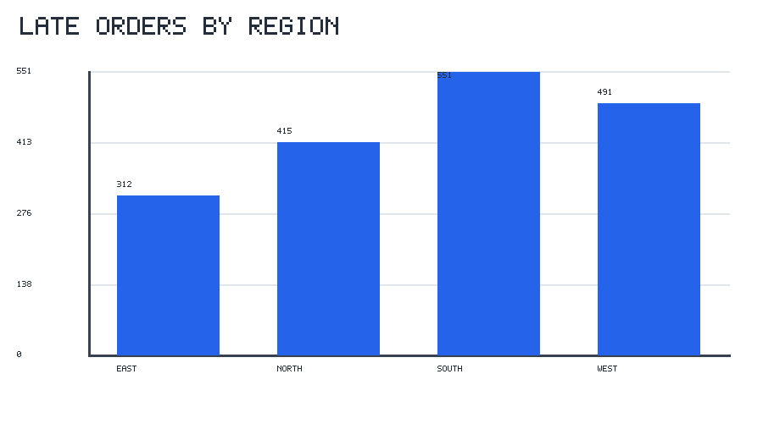

Late orders by shipping mode
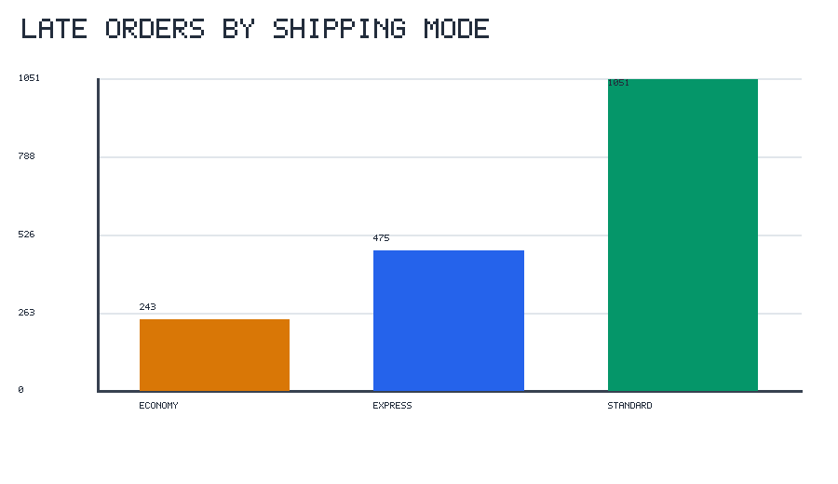

Monthly demand trend
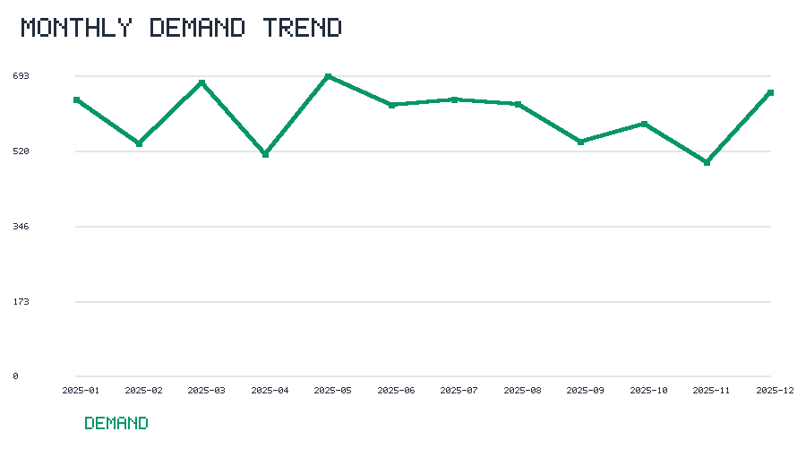

Top products by synthetic sales value
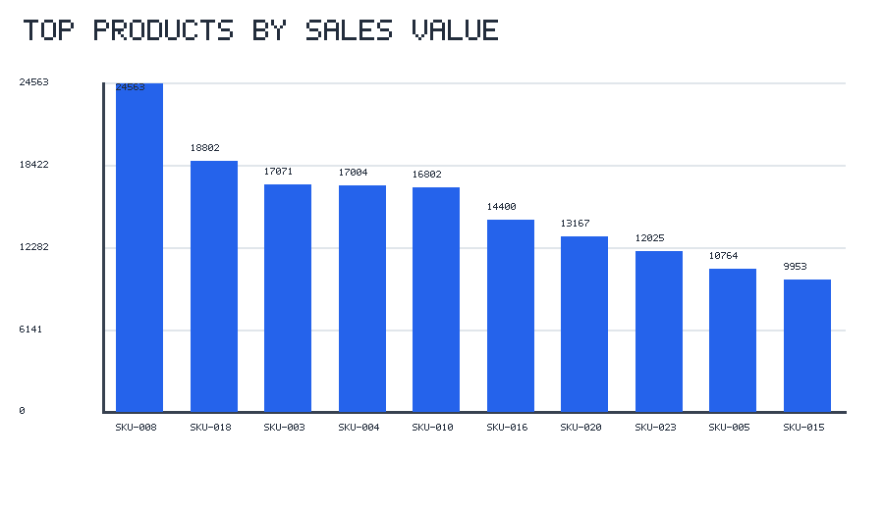

On-time delivery share by region
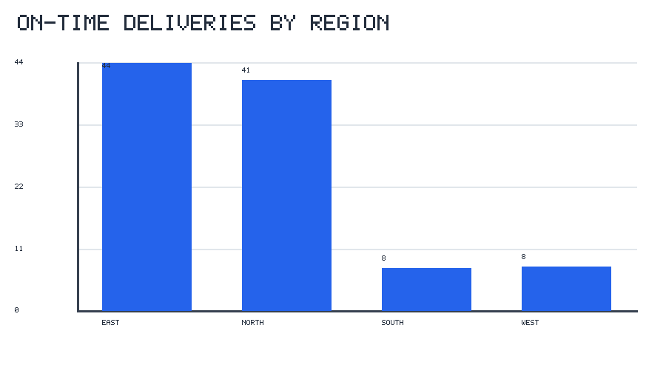

Weekly forecast test period
